**Database Design :**

* **Fact Table:** Transactions
  + Trans_ID (PK)
  + Invoice
  + InvoiceDate
  + CustomerID (FK)
  + StockCode (FK)
  + Quantity
  + TotalPrice
* **Dimension Tables:**
  + Customers
    - CustomerID (PK)
    - Country
  + Products
    - StockCode (PK)
    - Description
    - Price

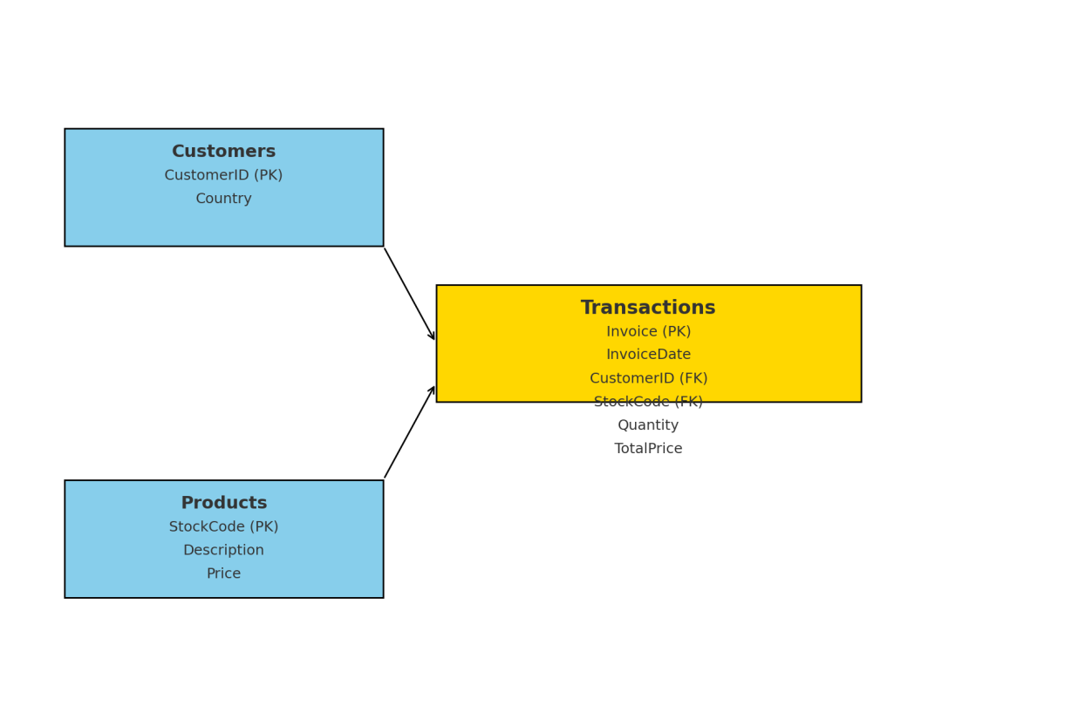

Trans_ID(PK)

**Star Schema Diagram** based on database design:

* **Fact Table:** Transactions
  + **Primary Key (PK):** Invoice
  + **Foreign Keys (FK):** CustomerID, StockCode
  + Includes InvoiceDate, Quantity, and TotalPrice
* **Dimension Tables:**
  + **Customers:** CustomerID (PK), Country
  + **Products:** StockCode (PK), Description, Price